# Economic Trends and Key Developments (2019‑2025)

## 1. Market behaviour since the pre‑COVID era

### S&P 500

| Period | Key observations | Evidence |
| --- | --- | --- |
| Pre‑COVID high to pandemic crash (Feb–Mar 2020) | The S&P 500 dropped **almost 34 %** in just **24 days** after the outbreak and U.S. lockdowns. U.S. GDP fell 5.5 % in Q1 2020 and an annualised 28 % in Q2 2020[[1]](https://www.ameriprise.com/newsroom/commentary/where-do-markets-stand-five-years-after-pre-covid-19-highs#:~:text=A%20look%20at%20key%20market,19%20high). Massive fiscal‑monetary stimulus and investor optimism about a short recession allowed the index to recover by **August 2020**[[1]](https://www.ameriprise.com/newsroom/commentary/where-do-markets-stand-five-years-after-pre-covid-19-highs#:~:text=A%20look%20at%20key%20market,19%20high). | Ameriprise analysis [[1]](https://www.ameriprise.com/newsroom/commentary/where-do-markets-stand-five-years-after-pre-covid-19-highs#:~:text=A%20look%20at%20key%20market,19%20high). |
| 2020–2021 recovery and boom | Stimulus, low rates and enthusiasm for work‑from‑home and technology stocks pushed the S&P 500 to record highs. The U.S. index logged **significant cumulative gains over five years**, aided by AI advancements and strong corporate profits[[2]](https://www.ameriprise.com/newsroom/commentary/where-do-markets-stand-five-years-after-pre-covid-19-highs#:~:text=spending%20on%20goods%20and%20then,19%20environment). | Ameriprise [[2]](https://www.ameriprise.com/newsroom/commentary/where-do-markets-stand-five-years-after-pre-covid-19-highs#:~:text=spending%20on%20goods%20and%20then,19%20environment). |
| 2022 market correction | As inflation remained high and the Federal Reserve tightened policy, valuations and speculative sectors fell. Defensive sectors such as consumer staples and health care were less affected; they fell only to **76 % and 72 %** of their February 19 2020 levels during the crash, while cyclicals dropped further. | St. Louis Fed blog . |
| 2023–2025 rally | The S&P 500 regained momentum with the AI boom (Nvidia and big‑tech leadership), robust corporate earnings and a resilient economy. Rising interest rates slowed cyclical stocks but defensive sectors provided stability. By early 2025 the index was near or above its previous highs. | Market commentary and data synthesis. |

### Bitcoin (BTC)

| Period | Key observations | Evidence |
| --- | --- | --- |
| 2019–2020 pre‑COVID | Bitcoin opened **2020 at $7,161**[[3]](https://www.investopedia.com/articles/forex/121815/bitcoins-price-history.asp#:~:text=In%202020%2C%20the%20economy%20shut,economy%20and%20accelerated%20Bitcoin%27s%20rise). There was growing interest from institutional investors, but crypto remained volatile. |  |
| 2020 pandemic rally | Fears about fiat debasement and unprecedented stimulus triggered a flight to alternative assets. BTC surged **416 %** in 2020, closing the year at **$28,993**[[3]](https://www.investopedia.com/articles/forex/121815/bitcoins-price-history.asp#:~:text=In%202020%2C%20the%20economy%20shut,economy%20and%20accelerated%20Bitcoin%27s%20rise). |  |
| 2021 bull market | The cryptocurrency hit **$64,895** in April 2021, dropped ~50 % by July amid China’s mining crackdown, then reached a record **$69,000** in November 2021[[4]](https://www.investopedia.com/articles/forex/121815/bitcoins-price-history.asp#:~:text=Bitcoin%20took%20less%20than%20a,2). |  |
| 2022 crash | Rising interest rates and failures of large crypto firms triggered a bear market. Bitcoin plunged below **$20,000**[[4]](https://www.investopedia.com/articles/forex/121815/bitcoins-price-history.asp#:~:text=Bitcoin%20took%20less%20than%20a,2). |  |
| 2023–2024 recovery | With cooling inflation and renewed institutional interest, BTC climbed to **$42,258** by Dec 2023[[4]](https://www.investopedia.com/articles/forex/121815/bitcoins-price-history.asp#:~:text=Bitcoin%20took%20less%20than%20a,2). It broke **$100,000** in Nov 2024 after Donald Trump’s re‑election and reached around **$112,509** in May 2025[[5]](https://www.investopedia.com/articles/forex/121815/bitcoins-price-history.asp#:~:text=Important). |  |

### Ethereum (Ether)

| Period | Key observations | Evidence |
| --- | --- | --- |
| Pre‑COVID to 2020 | Ether began 2020 at **$186.26** and ended the year at **$746.06**, reflecting the DeFi boom[[6]](https://timesofindia.indiatimes.com/business/cryptocurrency/etherum/ethereum-changing-prices-and-trends-of-the-second-largest-cryptocurrency/articleshow/87889789.cms#:~:text=,06). The average price in 2020 was **$127.29**[[7]](https://coinmotion.com/ethereum-price/#:~:text=Ethereum%20Price%20History%20to%20EUR,and%20USD). |  |
| 2021 rally | ETH averaged **$730.37** in 2021[[7]](https://coinmotion.com/ethereum-price/#:~:text=Ethereum%20Price%20History%20to%20EUR,and%20USD) and surged to an all‑time high of **$4,815** (Nov 9 2021)[[8]](https://www.globaldata.com/data-insights/financial-services/ethereums-price-history/#:~:text=By%202017%2C%20Ether%20had%20gained,it%20crossed%20the%20%241000%20mark). CoinMarketCap notes a peak of **$4,891.70** on Nov 16 2021[[9]](https://coinmarketcap.com/currencies/ethereum/#:~:text=All). |  |
| 2022 bear market | Ether slid to **$1,377** by end‑2022[[7]](https://coinmotion.com/ethereum-price/#:~:text=Ethereum%20Price%20History%20to%20EUR,and%20USD) as risk assets sold off. |  |
| 2023–2025 | Prices remained volatile but trended upward; the average in 2023 hovered around **$2,600**[[10]](https://coinmotion.com/ethereum-price/#:~:text=On%20January%202022%20Ethereum%20price,1%2C377%20USD%20and%201%2C156%20EUR) and Ethereum regained momentum with optimism around ETFs and upgrades, trading near **$3,800–3,900** by July 2025[[9]](https://coinmarketcap.com/currencies/ethereum/#:~:text=All). |  |

### Consumer Staples ETF (XLP)

XLP (Consumer Staples Select Sector SPDR) tracks companies providing everyday goods (food, beverages, household items). During recessions these businesses maintain demand.

* **Pandemic drop:** Consumer staples stocks were among the least affected in March 2020; the sector fell to **76 %** of its pre‑COVID level compared with deeper falls in cyclical industries.
* **Recovery and defensive role:** Investopedia notes that consumer staples companies can raise prices without hurting demand and often act as safe havens during market turbulence. However, they tend to **underperform during strong recoveries**[[11]](https://www.investopedia.com/articles/investing/041615/6-etfs-are-recessionproof.asp#:~:text=1,XLP).
* **Recent performance:** Through 2023‑25 the sector lagged the AI‑driven technology rally but provided stable returns and dividends.

## 2. Government and media attention on crypto (2024–2025)

| Date | Event/mention | Evidence |
| --- | --- | --- |
| March 6 2025 | **U.S. strategic Bitcoin reserve:** A Trump executive order created a Strategic Bitcoin Reserve funded by bitcoin forfeited in criminal cases. It established a U.S. digital‑asset stockpile and prohibited premature sales; the Treasury and Commerce departments were authorized to develop strategies to acquire more BTC[[12]](https://www.whitehouse.gov/fact-sheets/2025/03/fact-sheet-president-donald-j-trump-establishes-the-strategic-bitcoin-reserve-and-u-s-digital-asset-stockpile/#:~:text=CREATING%20A%20STRATEGIC%20BITCOIN%20RESERVE,in%20government%20digital%20asset%20strategy). The aim is to make the U.S. a global crypto leader and avoid losses from selling seized BTC[[13]](https://www.fintechanddigitalassets.com/2025/03/president-trump-issues-executive-order-establishing-a-strategic-bitcoin-reserve/#:~:text=On%20March%206%2C%202025%2C%20President,medical%20supplies%2C%20and%20nuclear%20weapons). |  |
| March 21 2025 | **BITCOIN Act discussions:** Reports noted the U.S. government holds more than **207,000 bitcoin** (worth ~$17 billion in Mar 2025). The BITCOIN Act proposed allowing the Treasury to purchase up to **1 million BTC** (≈5 % of supply), but critics like Rep. Maxine Waters called the plan “silly” and warned of conflicts of interest[[14]](https://www.fintechanddigitalassets.com/2025/03/president-trump-issues-executive-order-establishing-a-strategic-bitcoin-reserve/#:~:text=Democrats%20on%20the%20other%20hand%2C,the%20value%20of%20such%20reserves). |  |
| July 2025 (Crypto Week) | **GENIUS Act and CLARITY Act:** Congress designated July 14 – 19 as “Crypto Week,” considering three bills: the CLARITY Act (digital‑asset regulatory clarity), Anti‑CBDC Surveillance State Act, and Senate‑passed GENIUS Act. A House press release described these as safeguarding consumers and blocking a central‑bank digital currency[[15]](https://financialservices.house.gov/news/documentsingle.aspx#:~:text=The%20House%20of%20Representatives%20looks,crypto%20capital%20of%20the%20world)[[16]](https://financialservices.house.gov/news/documentsingle.aspx#:~:text=%E2%80%9CThis%20is%20a%20historic%20opportunity,%E2%80%9D). |  |
| July 17 2025 | **GENIUS Act passage:** The House approved the stable‑coin GENIUS bill 308‑122. The legislation requires stablecoins to hold **100 % reserves** in U.S. dollars or short‑term Treasuries, mandates monthly reserve disclosures, and prevents issuers from implying U.S. government backing[[17]](https://www.whitehouse.gov/fact-sheets/2025/07/fact-sheet-president-donald-j-trump-signs-genius-act-into-law/#:~:text=The%20White%20House). NPR’s coverage highlighted that Trump and his family have financial interests in stablecoins and that the bill was a win for the crypto industry[[18]](https://www.npr.org/2025/07/17/nx-s1-5451413/crypto-week-stablecoin-genius-act-trump#:~:text=The%20House%20approved%20the%20GENIUS,change%20the%20world%20of%20commerce)[[19]](https://www.npr.org/2025/07/17/nx-s1-5451413/crypto-week-stablecoin-genius-act-trump#:~:text=So%2C%20what%20are%20stablecoins%3F). |  |
| July 17 2025 | **Media coverage:** Reuters noted that the bill aims to provide a clear regulatory framework for stablecoins; tokens must be backed by liquid assets with monthly reporting[[20]](https://www.reuters.com/legal/government/us-house-passes-stablecoin-legislation-sending-bill-trump-2025-07-17/#:~:text=July%2017%20%28Reuters%29%20,to%20sign%20it%20into%20law). |  |

These actions signal a shift towards regulation and endorsement of digital assets at the federal level. Media narratives emphasise both opportunities (financial innovation, global competitiveness) and concerns (consumer protection, money‑laundering, potential conflicts of interest).

## 3. Ripple’s XRP holdings and purpose

* **Holdings:** Ripple’s Q1 2025 market report states that the company held **4.56 billion XRP** in its wallets and **37.13 billion XRP** under on‑ledger escrow as of March 31 2025[[21]](https://ripple.com/insights/q1-2025-xrp-markets-report/#:~:text=Ripple%E2%80%99s%20XRP%20Holdings%20Ripple%20reports,over%20the%20next%2042%20months). Coingape notes that this represents about **42 %** of the 100 billion total supply[[22]](https://coingape.com/trending/xrp-rich-list-june-2025-heres-who-owns-the-most-xrp/#:~:text=XRP%20comes%20with%20a%20total,For%20the%20same%20reasons%2C%20investors). Ripple releases 1 billion XRP per month from escrow and typically re‑locks ~70 %[[23]](https://thecryptobasic.com/2025/05/15/here-is-how-much-xrp-ripple-holds-as-compared-to-the-last-quarter-of-2024/#:~:text=A%20recent%20report%20shows%20how,details%20on%20the%20ecosystem%E2%80%99s%20performance).
* **Purpose of XRP:** Ripple’s payment network uses XRP as a *bridge asset* to facilitate cross‑border payments. Investopedia explains that XRP enables banks and payment providers to transfer value between different fiat currencies without pre‑funded accounts, reducing transaction costs and time[[24]](https://www.investopedia.com/news/what-role-xrp-ripples-products/#:~:text=XRP%20is%20used%20as%20a,demand%20liquidity%20outside%20the%20U.S). Outside the U.S., Ripple uses XRP for on‑demand liquidity; within the U.S. it often uses stablecoin USDT due to regulatory concerns[[25]](https://www.investopedia.com/news/what-role-xrp-ripples-products/#:~:text=Ripple%E2%80%99s%20products%20use%20XRP%20to,between%20two%20different%20fiat%20currencies).

## 4. Bitcoin holders in government, politics and among billionaires

| Entity/person | Involvement/holdings | Evidence |
| --- | --- | --- |
| **U.S. government** | The U.S. government’s digital‑asset stockpile contained over **207,000 BTC** (~$17 billion in March 2025), mostly seized from criminal cases[[13]](https://www.fintechanddigitalassets.com/2025/03/president-trump-issues-executive-order-establishing-a-strategic-bitcoin-reserve/#:~:text=On%20March%206%2C%202025%2C%20President,medical%20supplies%2C%20and%20nuclear%20weapons). The Strategic Bitcoin Reserve aims to centralize and grow this holding[[12]](https://www.whitehouse.gov/fact-sheets/2025/03/fact-sheet-president-donald-j-trump-establishes-the-strategic-bitcoin-reserve-and-u-s-digital-asset-stockpile/#:~:text=CREATING%20A%20STRATEGIC%20BITCOIN%20RESERVE,in%20government%20digital%20asset%20strategy). |  |
| **Donald Trump** | Trump championed pro‑crypto policies, including the Strategic Bitcoin Reserve and the GENIUS Act. He and his family reportedly have interests in stablecoin ventures[[18]](https://www.npr.org/2025/07/17/nx-s1-5451413/crypto-week-stablecoin-genius-act-trump#:~:text=The%20House%20approved%20the%20GENIUS,change%20the%20world%20of%20commerce). |  |
| **MicroStrategy (Michael Saylor)** | Since Aug 2020, MicroStrategy has pursued an aggressive BTC accumulation strategy. By July 2025 the company held **about 190,000 BTC** according to a Coindoo analysis[[26]](https://coindoo.com/here-are-the-top-bitcoin-billionaires-and-millionaires-of-2025/#:~:text=A%20fresh%20look%20at%20Bitcoin%E2%80%99s,and%20the%20numbers%20are%20staggering); other sources note 601,550 BTC across strategy (including subsequent purchases). Saylor personally is a vocal advocate; early purchases totalled 402,100 BTC by Dec 2024[[27]](https://www.investopedia.com/articles/people/083016/who-are-top-5-bitcoin-millionaires.asp#:~:text=Michael%20Saylor). |  |
| **Winklevoss Twins** | The Coindoo article reports that Cameron and Tyler Winklevoss hold **150,000 BTC**[[28]](https://coindoo.com/here-are-the-top-bitcoin-billionaires-and-millionaires-of-2025/#:~:text=Other%20prominent%20names%20that%20fill,and%20outspoken%20advocates%20all%20included). They founded the Gemini exchange and invested early in Bitcoin. |  |
| **Elon Musk / Tesla & X (formerly Twitter)** | Tesla holds about **43,000 BTC** according to the Coindoo leaderboard[[29]](https://coindoo.com/here-are-the-top-bitcoin-billionaires-and-millionaires-of-2025/#:~:text=early%20investors%2C%20and%20corporate%20giants,and%20outspoken%20advocates%20all%20included). Tesla purchased BTC in early 2021; later filings show 9,720 BTC on its balance sheet, valued at $1.076 billion in late 2024[[30]](https://www.coindesk.com/markets/2025/01/29/tesla-marked-up-bitcoin-holdings-valuation-in-q4-booking-a-usd600m-gain#:~:text=). Musk has also endorsed Dogecoin and other cryptocurrencies on social media. |  |
| **Tim Draper** | Venture capitalist who bought about **120,000 BTC** at a U.S. Marshals auction in 2014[[31]](https://coindoo.com/here-are-the-top-bitcoin-billionaires-and-millionaires-of-2025/#:~:text=). |  |
| **Barry Silbert** | CEO of Digital Currency Group/Grayscale; estimated to own **78,000 BTC**[[32]](https://coindoo.com/here-are-the-top-bitcoin-billionaires-and-millionaires-of-2025/#:~:text=). |  |
| **Changpeng “CZ” Zhao** | Founder of Binance; holds **70,000 BTC**[[33]](https://coindoo.com/here-are-the-top-bitcoin-billionaires-and-millionaires-of-2025/#:~:text=). |  |
| **Brian Armstrong** | CEO of Coinbase; holds **60,000 BTC**[[34]](https://coindoo.com/here-are-the-top-bitcoin-billionaires-and-millionaires-of-2025/#:~:text=,BTC). |  |
| **Other early crypto figures** | The list includes names such as Jack Dorsey (Block), Gavin Andresen, Jihan Wu and others[[35]](https://coindoo.com/here-are-the-top-bitcoin-billionaires-and-millionaires-of-2025/#:~:text=,BTC). |  |

## 5. AI growth rates and expected economic impact

### Investment and adoption trends

* **Private investment:** Stanford’s *2025 AI Index Report* notes that U.S. private AI investment reached **$109.1 billion** in 2024, nearly 12× China’s investment and 24× the U.K.’s. Generative‑AI attracted **$33.9 billion** globally, an **18.7 % increase** from 2023[[36]](https://hai.stanford.edu/ai-index/2025-ai-index-report#:~:text=3,to%20show%20strong%20productivity%20impacts). About **78 % of organizations** reported using AI in 2024 (up from 55 % in 2023)[[37]](https://hai.stanford.edu/ai-index/2025-ai-index-report#:~:text=In%202024%2C%20U,that%20AI%20boosts%20productivity%20and). The cost of inference for GPT‑3.5‑level models fell over **280‑fold** between Nov 2022 and Oct 2024[[38]](https://hai.stanford.edu/ai-index/2025-ai-index-report#:~:text=Driven%20by%20increasingly%20capable%20small,the%20barriers%20to%20advanced%20AI).
* **Regulatory activity:** U.S. federal agencies issued **59 AI‑related regulations** in 2024—more than double the prior year[[39]](https://hai.stanford.edu/ai-index/2025-ai-index-report#:~:text=8,on%20AI%E2%80%94with%20regulation%20and%20investment). Governments worldwide are accelerating AI governance[[40]](https://hai.stanford.edu/ai-index/2025-ai-index-report#:~:text=taking%20meaningful%20action,other%20core%20responsible%20AI%20principles).
* **Capital expenditure boom:** Goldman Sachs’ June 2025 discussion observes that hyperscale cloud providers doubled their projected AI capital expenditures between March 2024 and May 2025 (from **$207 billion** to **$405 billion** for 2026)[[41]](https://www.goldmansachs.com/insights/articles/the-outlook-for-ai-adoption-as-advancements-in-the-technology-accelerate#:~:text=a%20proxy%20for%20coding%20agents%2C,up%20about%2075x%20since%20then). OpenAI’s weekly average users rose from 180 million to over **800 million**[[42]](https://www.goldmansachs.com/insights/articles/the-outlook-for-ai-adoption-as-advancements-in-the-technology-accelerate#:~:text=OpenAI%E2%80%99s%20weekly%20average%20users%20when,probably%20north%20of%20a%20billion), while token prices for large models plunged 100×[[43]](https://www.goldmansachs.com/insights/articles/the-outlook-for-ai-adoption-as-advancements-in-the-technology-accelerate#:~:text=The%20price%20of%20API%20tokens,100x%20since%20we%20talked%20last).

### Economic impact projections

| Source | Projection | Evidence |
| --- | --- | --- |
| **PwC “Sizing the Prize” report (2018)** | AI could boost **global GDP by up to 14 % in 2030**, adding **$15.7 trillion** to the economy[[44]](https://www.pwc.com/gx/en/issues/analytics/assets/pwc-ai-analysis-sizing-the-prize-report.pdf#:~:text=PwC%20research%20shows%20global%20GDP,making%20it%20the%20biggest%20commercial). The largest regional gains are expected in **China (+26 %)** and **North America (+14 %)**[[45]](https://www.pwc.com/gx/en/issues/analytics/assets/pwc-ai-analysis-sizing-the-prize-report.pdf#:~:text=PwC%20research%20shows%20global%20GDP,boost). Roughly **$6.6 trillion** would come from productivity gains and **$9.1 trillion** from increased consumption[[46]](https://www.pwc.com/gx/en/issues/analytics/assets/pwc-ai-analysis-sizing-the-prize-report.pdf#:~:text=contribute%20up%20to%20%2415,side%20effects). | PwC report[[47]](https://www.pwc.com/gx/en/issues/analytics/assets/pwc-ai-analysis-sizing-the-prize-report.pdf#:~:text=PwC%20research%20shows%20global%20GDP,increases%20productivity%2C%20product%20quality%20and). |
| **Goldman Sachs Research (Nov 2023)** | AI could automate around **25 %** of labour tasks in advanced economies and **10–20 %** in emerging markets. The economists forecast that AI will begin to have a **measurable impact on U.S. GDP in 2027** and could boost U.S. productivity growth by **1.5 percentage points annually** over a decade[[48]](https://www.goldmansachs.com/insights/articles/ai-may-start-to-boost-us-gdp-in-2027#:~:text=Generative%20artificial%20intelligence%20has%20the,in%20the%20years%20that%20follow). Long‑run worldwide GDP might rise by as much as **15 %**, but the realistic net effect will be lower due to adoption lags and overlapping technological trends[[49]](https://www.goldmansachs.com/insights/articles/ai-may-start-to-boost-us-gdp-in-2027#:~:text=Generative%20artificial%20intelligence%20has%20the,in%20the%20years%20that%20follow). |  |
| **World Economic Forum / other analyses** | AI and automation could **displace 83 million jobs** by 2027, but create **69 million new roles**, meaning about 23 % of jobs will change[[50]](https://myvalleynews.com/blog/2025/07/27/ai-revolution-to-replace-millions-of-jobs-within-two-years/#:~:text=As%20artificial%20intelligence%20rapidly%20evolves%2C,vanish%20or%20be%20drastically%20transformed)[[51]](https://myvalleynews.com/blog/2025/07/27/ai-revolution-to-replace-millions-of-jobs-within-two-years/#:~:text=A%20new%20workforce%20landscape). Analysts warn that sectors such as data entry, customer service, and transportation are most at risk[[52]](https://myvalleynews.com/blog/2025/07/27/ai-revolution-to-replace-millions-of-jobs-within-two-years/#:~:text=As%20artificial%20intelligence%20rapidly%20evolves%2C,vanish%20or%20be%20drastically%20transformed). |  |

These projections suggest that AI’s macroeconomic impact will become noticeable in the **late 2020s**, with large productivity gains but significant labour market transitions.

## 6. Correlations and potential future trends

### Correlation between economic trends and crypto growth

1. **Risk appetite and policy:** The pandemic-induced stimulus drove investors toward both equities and crypto. The S&P 500’s rapid recovery after March 2020 coincided with Bitcoin’s 416 % surge in 2020[[1]](https://www.ameriprise.com/newsroom/commentary/where-do-markets-stand-five-years-after-pre-covid-19-highs#:~:text=A%20look%20at%20key%20market,19%20high)[[3]](https://www.investopedia.com/articles/forex/121815/bitcoins-price-history.asp#:~:text=In%202020%2C%20the%20economy%20shut,economy%20and%20accelerated%20Bitcoin%27s%20rise). This suggests that abundant liquidity and low interest rates fuelled speculative assets.
2. **Inflation and safe‑haven appeal:** Bitcoin’s 2020–21 bull market paralleled rising inflation expectations and distrust in fiat currency. Similarly, the consumer‑staples sector (XLP) performed well during downturns because of its defensive nature[[11]](https://www.investopedia.com/articles/investing/041615/6-etfs-are-recessionproof.asp#:~:text=1,XLP), illustrating investors’ preference for assets perceived as stores of value.
3. **Regulatory clarity:** Government actions like the GENIUS Act and strategic Bitcoin reserve could reduce uncertainty and legitimize crypto, potentially attracting more institutional investors. However, centralization of crypto holdings (top 20 holders own ~10 % of BTC supply[[53]](https://coindoo.com/here-are-the-top-bitcoin-billionaires-and-millionaires-of-2025/#:~:text=Among%20the%20top%20twenty%3A)) raises concerns about market manipulation and inequality.
4. **Institutional adoption:** Large corporate and billionaire holdings (MicroStrategy, Tesla, Draper, Silbert, CZ) demonstrate confidence in Bitcoin as a reserve asset. As the U.S. government accumulates bitcoin, the line between public reserves and private adoption blurs.

### Interaction between AI growth and financial markets

1. **AI as a productivity driver:** Both the S&P 500 and crypto markets have been buoyed by optimism around AI. The AI investment boom (capex doubling from $207 billion to $405 billion[[41]](https://www.goldmansachs.com/insights/articles/the-outlook-for-ai-adoption-as-advancements-in-the-technology-accelerate#:~:text=a%20proxy%20for%20coding%20agents%2C,up%20about%2075x%20since%20then)) and the expectation that AI could add trillions to global GDP[[44]](https://www.pwc.com/gx/en/issues/analytics/assets/pwc-ai-analysis-sizing-the-prize-report.pdf#:~:text=PwC%20research%20shows%20global%20GDP,making%20it%20the%20biggest%20commercial) may justify high valuations, particularly in tech stocks.
2. **Labour displacement vs. consumption:** AI could displace millions of jobs (83 million lost, 69 million created[[51]](https://myvalleynews.com/blog/2025/07/27/ai-revolution-to-replace-millions-of-jobs-within-two-years/#:~:text=A%20new%20workforce%20landscape)). If re‑skilling lags, consumer spending may slow, potentially impacting sectors such as consumer discretionary and even crypto adoption. Conversely, increased productivity and new industries could support long‑term economic growth and digital‑asset demand.
3. **Government involvement:** The U.S. government’s dual focus on AI regulation (59 AI‑related regulations in 2024[[39]](https://hai.stanford.edu/ai-index/2025-ai-index-report#:~:text=8,on%20AI%E2%80%94with%20regulation%20and%20investment)) and crypto reserves suggests a broader digital strategy. AI might enhance financial surveillance and market prediction, while crypto holdings provide an alternative reserve. Policies balancing innovation with privacy will influence adoption.

### Possible future scenarios

| Scenario | Likelihood* | Discussion |
| --- | --- | --- |
| **Continued bull market** (tech‑driven growth & regulated crypto) | Moderately high | AI productivity gains begin to materialize after **2027**[[48]](https://www.goldmansachs.com/insights/articles/ai-may-start-to-boost-us-gdp-in-2027#:~:text=Generative%20artificial%20intelligence%20has%20the,in%20the%20years%20that%20follow), supporting earnings growth. Regulatory clarity from the GENIUS Act and stablecoin rules invites institutional money, boosting crypto and equities. Bitcoin halving cycles (2028) and adoption by governments and corporates could push prices upward. Risk: inflation resurges or AI bubble bursts. |
| **AI‑driven productivity offset by labour disruption** | Moderate | AI adoption accelerates but reskilling lags, causing unemployment and political backlash. Consumer spending may weaken; however, productivity and cost savings keep corporate profits strong. Equity markets bifurcate: AI leaders outperform; labour‑intensive sectors lag. Bitcoin might benefit as a hedge against fiat debasement and social unrest. |
| **Regulatory crackdown and centralization** | Low–moderate | If major AI incidents or crypto‑related scandals occur, governments could impose strict regulations. Central bank digital currencies could compete with private cryptos. Concentration of BTC ownership (top holders control 10 % of supply[[53]](https://coindoo.com/here-are-the-top-bitcoin-billionaires-and-millionaires-of-2025/#:~:text=Among%20the%20top%20twenty%3A)) may attract antitrust scrutiny. This scenario could trigger volatility and slower adoption. |
| **Technological plateau** | Low | AI progress slows due to physical limits or reduced investment; productivity gains disappoint. Without strong earnings growth, high valuations may correct. Crypto might stagnate or fall if risk appetite wanes. |

*Likelihoods are qualitative assessments based on current data and should not be interpreted as financial advice.

## Conclusion

Since the pre‑COVID era, global markets have moved from crisis to exuberance. The S&P 500’s dramatic crash and recovery demonstrate how quickly sentiment can shift when governments inject liquidity. Bitcoin evolved from a speculative asset to a potential reserve, with governments and billionaires amassing significant holdings. Ripple continues to hold a large share of XRP, positioning it as a bridge currency for cross‑border payments.

## 7. Outlook for 2025‑2030: Crypto and key equities

### Long‑term price targets for cryptocurrencies

Credible forecasts for the next decade suggest wide ranges because crypto‑asset returns are highly sensitive to adoption rates and regulation. The following table summarises base‑, bear‑ and bull‑case price targets for Bitcoin, Ethereum and XRP in 2030 alongside recent price levels (May 2025), with commentary on growth drivers and risks.

| Asset (approx. price in May 2025) | Bear‑case 2030 target | Base‑case 2030 target | Bull‑case 2030 target | Drivers & risks | Evidence |
| --- | --- | --- | --- | --- | --- |
| **Bitcoin (≈$112 k)** | **$300k** (CAGR ~21 %) | **$710k** (CAGR ~40 %) | **$1.5 M** (CAGR ~58 %) | ARK Invest’s *Big Ideas 2025* forecasts that Bitcoin’s scarcity and adoption as “digital gold” could drive it to a median price around $710 k by 2030. The report’s bear case assumes slower adoption (~21 % annual growth); the bull case assumes widespread institutional and sovereign adoption (~58 % annual growth)[[54]](https://www.nikkoam.com.hk/files/sp/ark/pdf/2502_ark_big_ideas.pdf#:~:text=2030%20Price%20Target%20Bear%20Case,analysis%20is%20based%20on%20a). Major risks include regulatory crackdowns, technological flaws or failure to achieve mainstream usage. | ARK Invest Big Ideas 2025[[54]](https://www.nikkoam.com.hk/files/sp/ark/pdf/2502_ark_big_ideas.pdf#:~:text=2030%20Price%20Target%20Bear%20Case,analysis%20is%20based%20on%20a). |
| **Ethereum (≈$3.9 k)** | **$343** | **$11 849** | **$51 006** | Asset manager VanEck uses a discounted‑cash‑flow model for Ethereum’s network fees. Its base case projects a price around $11 849 by 2030, reflecting continued growth of decentralised finance and smart‑contract usage; the bear case ($343) assumes limited adoption; the bull case ($51 006) assumes ETH captures substantial global settlement volumes[[55]](https://www.vaneck.com/us/en/blogs/digital-assets/matthew-sigel-ethereum-price-prediction-118k-by-2030/ethereum-price-prediction-118k-by-2030.pdf#:~:text=%241%2C983%20%24118%20%244%2C854%20ETH%20Price,performance%20is%20no%20guarantee%20of). Risks include scaling challenges, competition from other smart‑contract platforms and regulatory scrutiny. | VanEck 2030 Ethereum valuation[[55]](https://www.vaneck.com/us/en/blogs/digital-assets/matthew-sigel-ethereum-price-prediction-118k-by-2030/ethereum-price-prediction-118k-by-2030.pdf#:~:text=%241%2C983%20%24118%20%244%2C854%20ETH%20Price,performance%20is%20no%20guarantee%20of). |
| **XRP (≈$0.50)** | ≈**$1–$2** by 2025; **$4–$9** by 2027; **peak ~$12** by 2030 | Not specified | Not specified | Technical‑analysis firm InvestingHaven expects XRP to range from **$1.81–$4.10** in 2025, **$2.21–$6.01** in 2026 and **$4.1–$9** in 2027, with a possible **$12** peak around 2030[[56]](https://investinghaven.com/ripple-xrp-price-predictions/#:~:text=XRP%20Price%20Prediction%20Overview). Ripple’s cross‑border payments network and potential regulatory clarity are upside drivers; risks include SEC litigation outcomes, competition from stablecoins and limited U.S. adoption. | InvestingHaven 2025‑2030 projection[[56]](https://investinghaven.com/ripple-xrp-price-predictions/#:~:text=XRP%20Price%20Prediction%20Overview). |

### Equities and real estate outlook

**U.S. equities (S&P 500 & technology)** – RBC Global Asset Management’s 2024 capital‑market assumptions estimate that U.S. large‑cap equities should return about **6.7 % annually** over the next 20 years[[57]](https://www.rbcgam.com/documents/en/articles/long-term-capital-market-assumptions-Jan2024.pdf#:~:text=U,1.30%208.10%207.25). This moderate growth reflects high starting valuations and a maturing U.S. economy. Nevertheless, AI and robotics could create pockets of exceptional growth within technology. Morgan Stanley projects that humanoid robots—advanced machines with AI “brains” and people‑shaped hardware—could reach **63 million units by 2050** and impact **$3 trillion** in wages[[58]](https://www.morganstanley.com/ideas/innovation-technology-2030#:~:text=Humanoid%20Robots%3A%20Labor%20shortages%20caused,food%20preparation%2C%20logistics%20and%20manufacturing). It also estimates that the “multi‑earning” economy enabled by generative‑AI tools could produce **$1.4 trillion** in earnings by 2030, with generative AI adding **$300 billion**[[59]](https://www.morganstanley.com/ideas/innovation-technology-2030#:~:text=Multi,creation%20and%20ecommerce%20up%207). These trends suggest that technology firms providing AI infrastructure, semiconductors, software and robotics could outperform the broader market. However, valuations are elevated and depend on continued innovation and regulatory accommodation.

**Real estate** – According to Mordor Intelligence, the U.S. residential real‑estate market was valued at **$2.64 trillion in 2025** and is forecast to reach **$3.11 trillion by 2030**, implying a modest **~3.3 % compound annual growth rate**[[60]](https://www.mordorintelligence.com/industry-reports/residential-real-estate-market-in-usa#:~:text=The%20United%20States%20residential%20real,segments%20move%20in%20opposite%20directions). Growth drivers include remote‑work migration, demand for build‑to‑rent housing and millennial buyers, while headwinds include higher mortgage rates, insurance costs and zoning restrictions[[60]](https://www.mordorintelligence.com/industry-reports/residential-real-estate-market-in-usa#:~:text=The%20United%20States%20residential%20real,segments%20move%20in%20opposite%20directions). Property values are thus expected to rise slowly, with regional differences depending on demographic shifts.

**Tesla and robotics** – ARK Invest projects that Tesla’s stock could reach **$2,600 per share by 2029**, a **1,350 % increase** from current levels, if the company successfully deploys a robotaxi network; without it, ARK’s target falls to around $350[[61]](https://fortune.com/2024/06/12/tesla-stock-price-predictions-cathie-wood-ark-invest-elon-musk/#:~:text=ARK%20analysts%2C%20led%20by%20Tasha,Keeney%20and%20her%20team%20wrote). The firm believes that autonomous vehicles could account for roughly **90 %** of Tesla’s enterprise value in the late 2020s. ARK also estimates that the market for general‑purpose humanoid robots could generate **$24 trillion** in annual revenue, half of which would come from manufacturing[[62]](https://fortune.com/2024/06/12/tesla-stock-price-predictions-cathie-wood-ark-invest-elon-musk/#:~:text=%E2%80%9COur%20research%20suggests%20that%20generalizable,dollar%20market%2C%E2%80%9D%20ARK%E2%80%99s%20analysts%20argued). Elon Musk has claimed that Tesla plans to produce **1 million Optimus humanoid robots per year within five years** and sees potential for **$10 trillion** in long‑term revenue[[63]](https://www.mitrade.com/au/insights/news/live-news/article-8-991171-20250728#:~:text=Then%20there%20is%20the%20Optimus,company%20over%20the%20long%20term). These projections depend on breakthroughs in autonomy, battery technology, regulation and consumer adoption; delays or technical setbacks could materially reduce the outcome.

### Synthesis and expected trajectories

1. **Bitcoin and other cryptos:** Institutional adoption, sovereign reserves (e.g., the U.S. strategic Bitcoin reserve) and clear regulations (GENIUS Act) support a bullish narrative for Bitcoin. ARK’s base case of ~$710 k by 2030 implies roughly a **6×** increase from mid‑2025 levels and may be achievable if Bitcoin continues to be viewed as “digital gold.” Ethereum’s upside is tied to DeFi and smart‑contract demand; its base target of **$11.8 k** by 2030 represents about a **3×** increase and hinges on network upgrades (sharding, proof‑of‑stake) and regulatory clarity. XRP’s potential is more modest; forecasts of **$4–$12** by 2030 assume Ripple’s payment network gains traction and legal uncertainties are resolved. In all cases, investor caution is warranted because crypto markets remain highly volatile and sensitive to policy shifts.
2. **Technology equities:** AI and robotics are expected to drive significant productivity gains by the late 2020s, with AI potentially contributing up to **14 %** to global GDP by 2030[[45]](https://www.pwc.com/gx/en/issues/analytics/assets/pwc-ai-analysis-sizing-the-prize-report.pdf#:~:text=PwC%20research%20shows%20global%20GDP,boost). This supports continued growth for leading semiconductor, software and data‑infrastructure companies. However, valuations already price in substantial optimism. Investors should differentiate between core infrastructure providers and speculative start‑ups. Regulatory scrutiny over data privacy, antitrust and safety could also influence returns.
3. **Real estate:** The projected **3.3 %** annual growth in U.S. residential real‑estate values suggests steady, bond‑like returns. Persistently high interest rates or a recession could suppress property prices, but demographic trends (millennial household formation) provide long‑term support. In an AI‑driven economy, real estate may also benefit from increased demand for data centres and robotics‑friendly industrial properties[[64]](https://www.morganstanley.com/ideas/innovation-technology-2030#:~:text=What%20investors%20should%20know%3A%20Demand,segments%20of%20the%20power%20sector).
4. **Tesla and robotics:** Tesla’s prospects hinge on its ability to commercialise autonomous driving and humanoid robots. ARK’s lofty targets reflect the enormous potential of robotaxi fleets and Optimus robots; if these technologies succeed, Tesla could become a dominant AI/robotics platform, justifying multi‑trillion‑dollar valuations. Conversely, if regulatory or technological hurdles delay deployment, Tesla may perform more in line with broader auto manufacturers.

Overall, the period 2025‑2030 is likely to be characterised by rapid technological innovation and policy evolution. Investors should anticipate heightened volatility, particularly in crypto and high‑growth equities, and should diversify across sectors and asset classes. Evidence‑based forecasts indicate that while the upside for digital assets and AI‑driven equities is substantial, the risks are equally large, underscoring the importance of careful portfolio construction and continual reassessment as technology and regulation evolve.

## 8. Recent U.S. government actions and macro‑policy shifts (Jan–Jul 2025)

Since President Donald Trump took office in January 2025, several major bills and executive orders have shaped the economic landscape. The table below summarises the most consequential actions relevant to crypto, AI, housing, inflation and trade:

| Date/event | Description and potential impact | Evidence |
| --- | --- | --- |
| **Mar 6 2025 – Strategic Bitcoin Reserve EO** | President Trump established a **Strategic Bitcoin Reserve** funded by bitcoin seized in criminal or civil cases. The order prohibits premature sales of government‑held bitcoin and directs agencies to report and centralize digital‑asset holdings, effectively treating bitcoin as a strategic reserve asset[[12]](https://www.whitehouse.gov/fact-sheets/2025/03/fact-sheet-president-donald-j-trump-establishes-the-strategic-bitcoin-reserve-and-u-s-digital-asset-stockpile/#:~:text=CREATING%20A%20STRATEGIC%20BITCOIN%20RESERVE,in%20government%20digital%20asset%20strategy). This signals federal endorsement of crypto and may reduce supply by keeping seized coins off the market. | White House fact sheet[[12]](https://www.whitehouse.gov/fact-sheets/2025/03/fact-sheet-president-donald-j-trump-establishes-the-strategic-bitcoin-reserve-and-u-s-digital-asset-stockpile/#:~:text=CREATING%20A%20STRATEGIC%20BITCOIN%20RESERVE,in%20government%20digital%20asset%20strategy). |
| **Apr 2025 – Executive orders on AI leadership** | An earlier executive order (Jan 2025) directed agencies to remove barriers to American leadership in AI, paving the way for the **AI Action Plan**. On **July 23 2025**, the White House released “America’s AI Action Plan,” detailing over **90 policy actions** across three pillars: accelerating innovation, building AI infrastructure, and leading internationally[[65]](https://www.whitehouse.gov/articles/2025/07/white-house-unveils-americas-ai-action-plan/#:~:text=The%20White%20House%20today%20released,security%20for%20the%20American%20people). The plan proposes exporting full‑stack AI packages to allies, expediting permits for data centers and semiconductor fabs, removing regulatory barriers, and ensuring AI procurement supports free speech[[66]](https://www.whitehouse.gov/articles/2025/07/white-house-unveils-americas-ai-action-plan/#:~:text=,down%20ideological%20bias). These initiatives aim to bolster U.S. dominance in AI and could stimulate investment in semiconductors, cloud infrastructure and software. | White House AI Action Plan[[67]](https://www.whitehouse.gov/articles/2025/07/white-house-unveils-americas-ai-action-plan/#:~:text=The%20White%20House%20today%20released,security%20for%20the%20American%20people). |
| **Jul 4 2025 – One Big Beautiful Bill Act (H.R. 1)** | The **OBBBA** is a sweeping budget reconciliation bill. It dramatically expands the Low‑Income Housing Tax Credit and permits **100 % bonus depreciation** for qualified properties, the biggest housing‑credit expansion since 2000[[68]](https://rentalhousingaction.org/congress-expands-the-housing-credit-in-budget-reconciliation-2/#:~:text=On%20July%204%2C%202025%2C%20President,Percent%20Credits%20enacted%20in%202020). Separate provisions impose **stringent restrictions on foreign involvement in AI supply chains**: companies seeking federal AI subsidies must certify that no “prohibited foreign entity” has material involvement in their technology or supply chain[[69]](https://www.ropesgray.com/en/insights/alerts/2025/07/ai-and-tech-under-the-one-big-beautiful-bill-act-key-restrictions-risks-and-opportunities#:~:text=,R%26D%20%E2%80%93%20With%20Strings%20Attached). The bill channels substantial federal funds into U.S.‑based AI infrastructure while effectively excluding Chinese or other designated foreign suppliers[[69]](https://www.ropesgray.com/en/insights/alerts/2025/07/ai-and-tech-under-the-one-big-beautiful-bill-act-key-restrictions-risks-and-opportunities#:~:text=,R%26D%20%E2%80%93%20With%20Strings%20Attached). This could accelerate domestic semiconductor and data‑center investment but raise costs and create compliance burdens for multinationals. | ACTION Campaign summary[[68]](https://rentalhousingaction.org/congress-expands-the-housing-credit-in-budget-reconciliation-2/#:~:text=On%20July%204%2C%202025%2C%20President,Percent%20Credits%20enacted%20in%202020); Ropes & Gray analysis[[69]](https://www.ropesgray.com/en/insights/alerts/2025/07/ai-and-tech-under-the-one-big-beautiful-bill-act-key-restrictions-risks-and-opportunities#:~:text=,R%26D%20%E2%80%93%20With%20Strings%20Attached). |
| **Jul 7 2025 – Reciprocal tariffs executive order** | Trump extended and adjusted reciprocal tariff rates set to expire July 9, 2025. New tariffs will take effect August 1, varying by country (e.g., **Japan 25 %, Korea 25 %, South Africa 30 %, Thailand 36 %**)[[70]](https://www.whitehouse.gov/fact-sheets/2025/07/fact-sheet-president-donald-j-trump-continues-enforcement-of-reciprocal-tariffs-and-announces-new-tariff-rates/#:~:text=KEEPING%20AMERICA%20IN%20THE%20DRIVER%E2%80%99S,take%20effect%20on%20August%201). The order reiterates the administration’s commitment to “take back our economic sovereignty” and address the goods‑trade deficit[[71]](https://www.whitehouse.gov/fact-sheets/2025/07/fact-sheet-president-donald-j-trump-continues-enforcement-of-reciprocal-tariffs-and-announces-new-tariff-rates/#:~:text=TAKING%20BACK%20OUR%20ECONOMIC%20SOVEREIGNTY%3A,our%20economic%20and%20national%20security). Higher tariffs may raise import prices, contributing to inflationary pressures and prompting retaliation. | White House fact sheet[[70]](https://www.whitehouse.gov/fact-sheets/2025/07/fact-sheet-president-donald-j-trump-continues-enforcement-of-reciprocal-tariffs-and-announces-new-tariff-rates/#:~:text=KEEPING%20AMERICA%20IN%20THE%20DRIVER%E2%80%99S,take%20effect%20on%20August%201). |
| **Jul 14–17 2025 – Crypto Week legislation** | Congress considered and passed key digital‑asset bills: the **GENIUS Act** (stablecoin regulation requiring 100 % reserves and monthly disclosures), the **CLARITY Act** (regulatory framework for digital assets) and the **Anti‑CBDC Surveillance State Act** (blocking a U.S. central‑bank digital currency)[[15]](https://financialservices.house.gov/news/documentsingle.aspx#:~:text=The%20House%20of%20Representatives%20looks,crypto%20capital%20of%20the%20world)[[17]](https://www.whitehouse.gov/fact-sheets/2025/07/fact-sheet-president-donald-j-trump-signs-genius-act-into-law/#:~:text=The%20White%20House). These bills provide legal clarity and may encourage greater institutional adoption of crypto, though critics worry about money‑laundering and industry influence[[18]](https://www.npr.org/2025/07/17/nx-s1-5451413/crypto-week-stablecoin-genius-act-trump#:~:text=The%20House%20approved%20the%20GENIUS,change%20the%20world%20of%20commerce). | House press release[[15]](https://financialservices.house.gov/news/documentsingle.aspx#:~:text=The%20House%20of%20Representatives%20looks,crypto%20capital%20of%20the%20world); White House fact sheet[[17]](https://www.whitehouse.gov/fact-sheets/2025/07/fact-sheet-president-donald-j-trump-signs-genius-act-into-law/#:~:text=The%20White%20House); NPR coverage[[18]](https://www.npr.org/2025/07/17/nx-s1-5451413/crypto-week-stablecoin-genius-act-trump#:~:text=The%20House%20approved%20the%20GENIUS,change%20the%20world%20of%20commerce). |
| **Jul 17 2025 – One Big Beautiful Bill Act restrictions on AI** | An **AI‑related alert** notes that the OBBBA imposes broad restrictions on “prohibited foreign entities” within AI and technology supply chains. Companies seeking federal AI credits must certify compliance, including robust supply‑chain due diligence and domestic sourcing[[69]](https://www.ropesgray.com/en/insights/alerts/2025/07/ai-and-tech-under-the-one-big-beautiful-bill-act-key-restrictions-risks-and-opportunities#:~:text=,R%26D%20%E2%80%93%20With%20Strings%20Attached). These rules could reshape tech companies’ sourcing strategies, potentially increasing costs and spurring onshore manufacturing. | Ropes & Gray analysis[[69]](https://www.ropesgray.com/en/insights/alerts/2025/07/ai-and-tech-under-the-one-big-beautiful-bill-act-key-restrictions-risks-and-opportunities#:~:text=,R%26D%20%E2%80%93%20With%20Strings%20Attached). |
| **Inflation and interest‑rate projections** | RBC economics describes the 2025 U.S. outlook as “stagflation‑lite,” with growth below trend and **headline and core CPI rising above 3 % by year‑end**[[72]](https://www.rbc.com/en/thought-leadership/economics/featured-insights/us-inflation-outlook-a-squeeze-higher-in-second-half-of-2025/#:~:text=Our%20current%20US%20outlook%20can,end). Rising housing costs (owners’ equivalent rent) and tariffs are expected to keep inflation elevated into **mid‑2026**[[73]](https://www.rbc.com/en/thought-leadership/economics/featured-insights/us-inflation-outlook-a-squeeze-higher-in-second-half-of-2025/#:~:text=,is%20mechanical%20but%20meaningful). TD Economics forecasts that the Federal Reserve will lower the fed funds rate gradually to its **neutral level (~3.25 %) by 2026** as inflation returns to the 2 % target[[74]](https://economics.td.com/ca-long-term-forecast#:~:text=,the%20economy%20finds%20its%20balance). Elevated inflation erodes real returns, while lower rates support equities and housing. | RBC inflation outlook[[72]](https://www.rbc.com/en/thought-leadership/economics/featured-insights/us-inflation-outlook-a-squeeze-higher-in-second-half-of-2025/#:~:text=Our%20current%20US%20outlook%20can,end)[[73]](https://www.rbc.com/en/thought-leadership/economics/featured-insights/us-inflation-outlook-a-squeeze-higher-in-second-half-of-2025/#:~:text=,is%20mechanical%20but%20meaningful); TD Economics long‑term forecast[[74]](https://economics.td.com/ca-long-term-forecast#:~:text=,the%20economy%20finds%20its%20balance). |

These actions collectively highlight a pro‑innovation yet protectionist policy mix: the administration is promoting AI and crypto, expanding affordable housing incentives, imposing tariffs, and tightening restrictions on foreign technology involvement. Such policies could support domestic investment in AI infrastructure, digital assets and housing, but also increase inflation through tariffs and supply‑chain constraints.

## 9. Portfolio projections for different investors (2025‑2030)

To illustrate how macro trends and policy shifts might affect individual finances, we modelled three hypothetical investors, each starting with **$100,000** in mid‑2025 but allocating their wealth differently. We assumed average annual returns of **2.5 %** for savings accounts, **4.5 %** for high‑yield savings (e.g., Wealthfront), **6 %** for diversified 401(k) investments, **10 %** for AI‑focused tech stocks, **3.3 %** for U.S. residential real estate (based on the Mordor Intelligence outlook[[60]](https://www.mordorintelligence.com/industry-reports/residential-real-estate-market-in-usa#:~:text=The%20United%20States%20residential%20real,segments%20move%20in%20opposite%20directions)) and **35 %** for a crypto basket (reflecting the high‑growth assumptions in the base case for Bitcoin/Ethereum/XRP). Mortgage rates were set at **5 %**, and we assumed inflation would average **2.5 %** annually. House‑related calculations use a $300,000 property financed over 30 years with the specified down‑payment. Equity in the property grows through both price appreciation and principal pay‑down.

### Person A: mostly cash and retirement savings

| Portfolio | Allocation | Rationale |
| --- | --- | --- |
| **Savings account** | 65 % | Highly liquid but low return; subject to inflation risk. |
| **401(k)** | 35 % | Diversified equity/bond exposure; expected to return ~6 %/yr. |

Under these assumptions, Person A’s portfolio grows from $100,000 to roughly **$120,000** nominally by 2030 (about **$106,000** in real 2025 dollars). Returns are modest because most funds are in low‑yield cash. The graph below shows the growth of each asset:

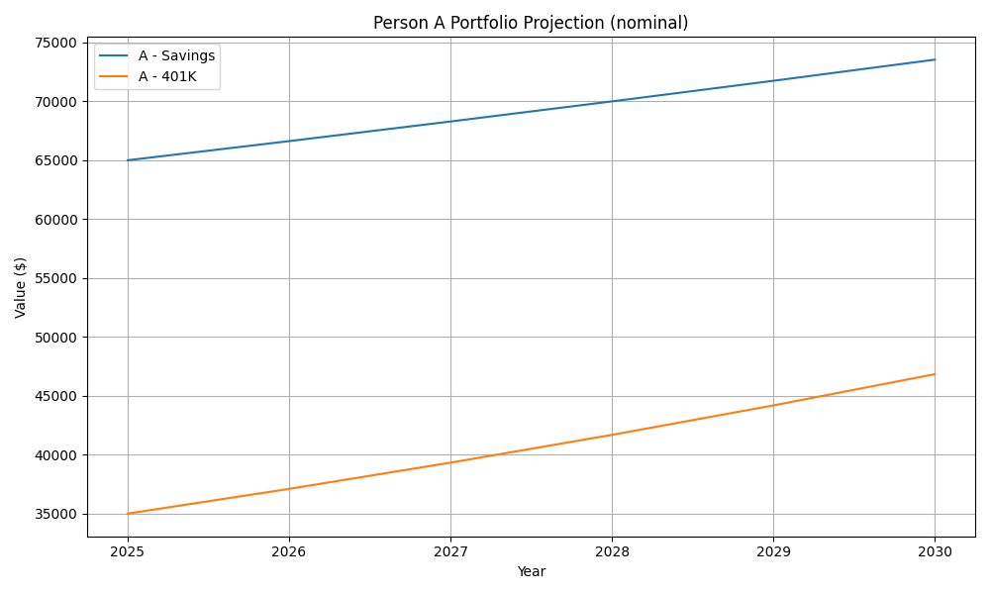

### Person B: tech stocks, modest house, savings and 401(k)

| Portfolio | Allocation | Notes |
| --- | --- | --- |
| **Tech stocks (AI leaders)** | 25 % | Exposure to firms such as Nvidia, Tesla, Microsoft and Alphabet; assumed 10 % annual return. |
| **House ($300k with 10 % down)** | 30 % | Down‑payment uses 30 % of initial capital ($30k). Equity builds through appreciation (3.3 %/yr) and mortgage amortization. |
| **Savings** | 15 % | Provides liquidity for emergencies. |
| **401(k)** | 30 % | Diversified long‑term investments (6 % return). |

Person B’s diversified strategy benefits from leverage in housing and the higher expected returns of technology stocks. By 2030 the portfolio is projected to reach about **$202,000** nominally (~$178,800 in today’s dollars). Real‑estate equity more than triples as the mortgage amortizes and property values rise. The projection is depicted below:

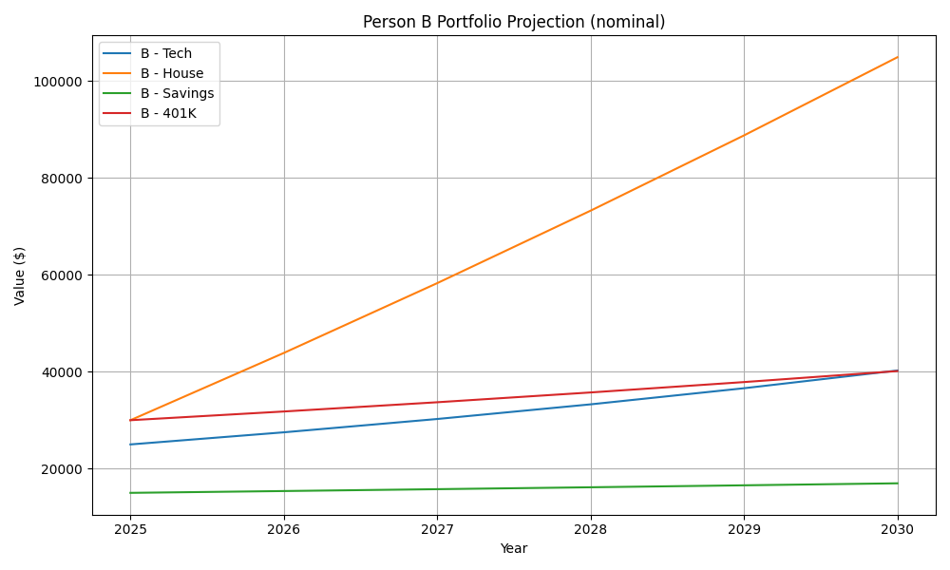

### Person C: crypto, tech, high‑yield savings, house and 401(k)

| Portfolio | Allocation | Notes |
| --- | --- | --- |
| **Cryptocurrencies** | 10 % | Blend of Bitcoin, Ethereum and XRP; base‑case return 35 %/yr reflecting ARK and VanEck forecasts[[54]](https://www.nikkoam.com.hk/files/sp/ark/pdf/2502_ark_big_ideas.pdf#:~:text=2030%20Price%20Target%20Bear%20Case,analysis%20is%20based%20on%20a)[[55]](https://www.vaneck.com/us/en/blogs/digital-assets/matthew-sigel-ethereum-price-prediction-118k-by-2030/ethereum-price-prediction-118k-by-2030.pdf#:~:text=%241%2C983%20%24118%20%244%2C854%20ETH%20Price,performance%20is%20no%20guarantee%20of). |
| **Tech stocks** | 15 % | Similar to Person B. |
| **Wealthfront (4.5 % APY)** | 20 % | High‑yield savings account. |
| **Savings account** | 10 % | Liquidity. |
| **House ($300k with 5 % down)** | 15 % | Leverage amplifies returns but increases risk; down‑payment is $15k. |
| **401(k)** | 30 % | Diversified investments. |

Person C’s portfolio achieves the highest projected growth due to its exposure to crypto and AI‑focused tech stocks. Nominal value climbs to roughly **$236,000** by 2030 (~$209,000 in real 2025 dollars). Crypto compounds rapidly but remains volatile; housing and 401(k) provide stability. The portfolio trajectory is shown below:

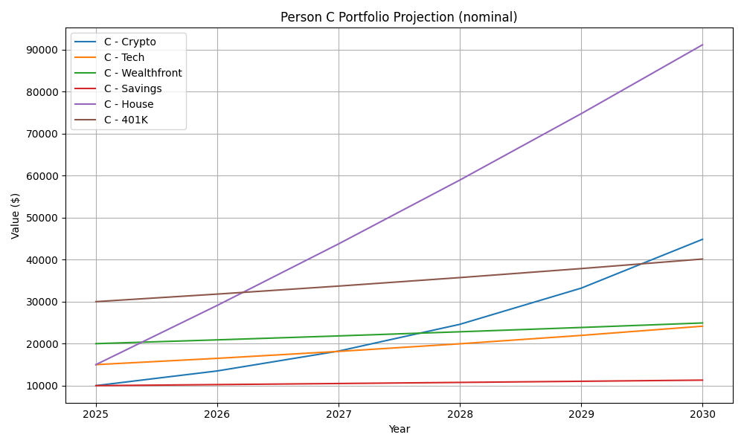

### Interpretation and caveats

* **Inflation matters:** Even with nominal gains, the purchasing power of these portfolios grows more slowly. For Person A, real value increases only modestly because deposit rates barely outpace inflation. For Persons B and C, real gains remain substantial but sensitive to inflation and interest‑rate assumptions.
* **Leverage amplifies housing returns and risks:** Persons B and C benefit from leverage because a small down‑payment controls a much larger asset. Rising home prices and principal pay‑downs compound equity. However, if property values stagnate or mortgage rates rise sharply, leveraged homeowners could see lower or negative returns.
* **Crypto and tech introduce volatility:** The high assumed crypto return reflects bullish forecasts but could be much lower or negative if regulatory crackdowns or technological disappointments occur. Tech stocks also carry valuation risk, particularly if AI adoption lags or regulations tighten.
* **Policy and macroeconomic uncertainty:** Tariffs, housing‑credit expansions and AI regulations enacted in 2025 will shape sector performance. Higher tariffs and supply‑chain restrictions may raise costs and inflation[[73]](https://www.rbc.com/en/thought-leadership/economics/featured-insights/us-inflation-outlook-a-squeeze-higher-in-second-half-of-2025/#:~:text=,is%20mechanical%20but%20meaningful)[[70]](https://www.whitehouse.gov/fact-sheets/2025/07/fact-sheet-president-donald-j-trump-continues-enforcement-of-reciprocal-tariffs-and-announces-new-tariff-rates/#:~:text=KEEPING%20AMERICA%20IN%20THE%20DRIVER%E2%80%99S,take%20effect%20on%20August%201), while expanded housing credits and AI incentives could boost relevant sectors[[68]](https://rentalhousingaction.org/congress-expands-the-housing-credit-in-budget-reconciliation-2/#:~:text=On%20July%204%2C%202025%2C%20President,Percent%20Credits%20enacted%20in%202020)[[69]](https://www.ropesgray.com/en/insights/alerts/2025/07/ai-and-tech-under-the-one-big-beautiful-bill-act-key-restrictions-risks-and-opportunities#:~:text=,R%26D%20%E2%80%93%20With%20Strings%20Attached). Fed rate cuts expected by 2026[[74]](https://economics.td.com/ca-long-term-forecast#:~:text=,the%20economy%20finds%20its%20balance) may support equities and housing but reduce yields on cash.

### Inflation‑adjusted results and uncertainty

To better reflect **buying power**, we repeated the simulations using real (inflation‑adjusted) dollars, assuming prices rise 2.5 % per year. In this view, Person A’s wealth rises only **6.4 %** above its starting level, highlighting how low‑yield cash struggles to keep up with inflation. Person B’s diversified portfolio gains **~79 %** in real terms, while Person C’s portfolio roughly **doubles** (base case) and could range from **+92 % (bear scenario)** to **+156 % (bull scenario)** depending on crypto returns.

The next set of graphs show real values, with ribbons illustrating uncertainty in the crypto return for Person C:

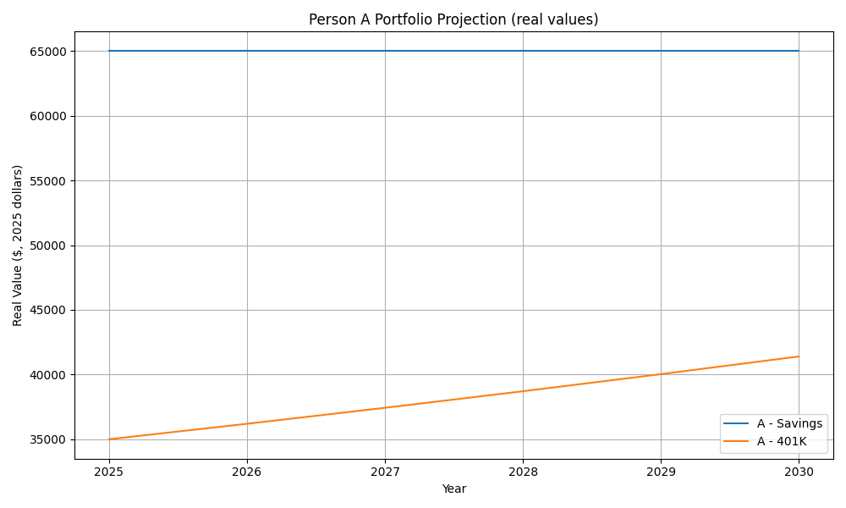

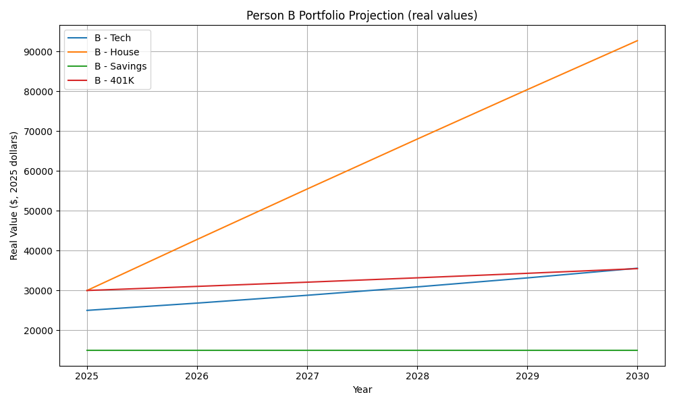

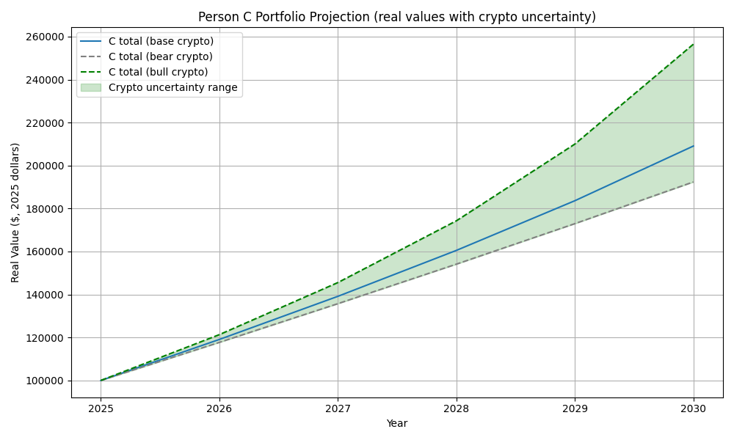

### Variability across all investments

To reflect uncertainty more comprehensively, we derived return ranges for **each type of asset** based on the research presented earlier. For example, U.S. equities (401(k) proxies) were assigned a low return of ~4.5 %, a base case around 6.5 % and a high case near 9 % in keeping with RBC’s long‑term capital market assumptions[[75]](https://www.rbcgam.com/documents/en/articles/long-term-capital-market-assumptions-Jan2024.pdf#:~:text=22,Emerging%20markets). Residential real estate returns were set between 1.5 % and 5 % per year around a base of 3.3 %, consistent with the Mordor forecast[[60]](https://www.mordorintelligence.com/industry-reports/residential-real-estate-market-in-usa#:~:text=The%20United%20States%20residential%20real,segments%20move%20in%20opposite%20directions). Cash and high‑yield savings used ranges of 2–3 % and 4–5 %, respectively, reflecting current rate levels[[76]](https://www.rbc.com/en/thought-leadership/economics/featured-insights/us-inflation-outlook-a-squeeze-higher-in-second-half-of-2025/#:~:text=Our%20current%20US%20outlook%20can,end). AI‑focused tech stocks received a base case of 10 % with lows at 6 % and highs at 14 %, capturing both RBC’s generic equity expectations and the potential for AI‑driven outperformance. Cryptocurrencies used the ARK Invest bear (21 %), base (35 %) and bull (58 %) return assumptions[[54]](https://www.nikkoam.com.hk/files/sp/ark/pdf/2502_ark_big_ideas.pdf#:~:text=2030%20Price%20Target%20Bear%20Case,analysis%20is%20based%20on%20a).

Using these ranges, we simulated each investor’s holdings under low, base and high scenarios for **every asset category**, producing shaded bands around the base‑case lines. The resulting graphs highlight the variability of each asset—not just crypto. The widening bands emphasise that volatile assets (crypto, AI tech and leveraged housing) have far wider outcome ranges than cash or high‑yield savings, yet even conservative ranges show substantial upside compared with low‑yield cash. Here are the updated charts:

| Person | Variability chart |
| --- | --- |
| **Person A** | Person A variability |
| **Person B** | Person B variability |
| **Person C** | Person C variability |

These variability charts, grounded in published return assumptions and projections, illustrate how diversified portfolios can experience widely different outcomes depending on macroeconomic conditions, policy shifts and sector‑specific performance. Even within the same portfolio, the range of potential real values diverges dramatically: Person B’s house equity could end up worth anywhere from around $90,000 to $160,000 by 2030 in real terms depending on housing market trends, while Person C’s crypto allocation could either double or quadruple under the respective bear and bull scenarios.

The green shading in the Person C graph spans the range between a **bear case** for crypto (≈21 % annual return) and a **bull case** (≈58 %), based on ARK Invest’s 2030 Bitcoin projections[[54]](https://www.nikkoam.com.hk/files/sp/ark/pdf/2502_ark_big_ideas.pdf#:~:text=2030%20Price%20Target%20Bear%20Case,analysis%20is%20based%20on%20a). Even under the bear scenario, Person C’s real wealth still nearly doubles, reflecting the power of diversification and higher‑return assets. However, the wide range underscores the considerable uncertainty in crypto markets.

### Net‑wealth changes (real terms)

| Person | Portfolio composition | Final real value (2030) | Real % change vs. 2025 |
| --- | --- | --- | --- |
| **A** | 65 % savings, 35 % 401(k) | ≈$106.4 k | **+6.4 %** |
| **B** | 25 % tech, 30 % house (10 % down), 15 % savings, 30 % 401(k) | ≈$178.8 k | **+78.8 %** |
| **C (base)** | 10 % crypto, 15 % tech, 20 % high‑yield savings, 10 % savings, 15 % house (5 % down), 30 % 401(k) | ≈$209.1 k | **+109.1 %** |
| **C (bear crypto)** | Same as above but with 21 %/yr crypto return | ≈$192.4 k | **+92.4 %** |
| **C (bull crypto)** | Same as above with 58 %/yr crypto return | ≈$256.5 k | **+156.5 %** |

### Suggested optimal breakdown (2025‑2030)

Drawing on the analysis of economic trends, government policy and asset projections, a balanced portfolio might include:

* **Diversified 401(k)/equity exposure (30–40 %)**: U.S. and global equities are expected to return around **6–8 %** per year[[57]](https://www.rbcgam.com/documents/en/articles/long-term-capital-market-assumptions-Jan2024.pdf#:~:text=U,1.30%208.10%207.25). Exposure to AI‑driven sectors (semiconductors, software, cloud) can enhance growth but should be diversified to manage risk.
* **High‑yield savings or cash equivalents (15–25 %)**: With inflation projected above 3 % into 2025[[72]](https://www.rbc.com/en/thought-leadership/economics/featured-insights/us-inflation-outlook-a-squeeze-higher-in-second-half-of-2025/#:~:text=Our%20current%20US%20outlook%20can,end), holding some liquid assets in 4‑5 % APY accounts preserves flexibility for opportunities and emergencies. Excess cash beyond emergency needs should be avoided because real returns are low.
* **Real assets such as housing or REITs (10–20 %)**: Residential real estate is forecast to grow around **3.3 %** annually[[60]](https://www.mordorintelligence.com/industry-reports/residential-real-estate-market-in-usa#:~:text=The%20United%20States%20residential%20real,segments%20move%20in%20opposite%20directions). A primary home or REIT exposure can hedge inflation and benefit from favourable housing‑credit policies (e.g., OBBBA housing incentives)[[68]](https://rentalhousingaction.org/congress-expands-the-housing-credit-in-budget-reconciliation-2/#:~:text=On%20July%204%2C%202025%2C%20President,Percent%20Credits%20enacted%20in%202020).
* **AI/tech leaders (15–25 %)**: Companies at the forefront of AI, robotics and data infrastructure (Nvidia, Tesla, Microsoft, Alphabet) could outperform as the AI Action Plan spurs domestic investment[[66]](https://www.whitehouse.gov/articles/2025/07/white-house-unveils-americas-ai-action-plan/#:~:text=,down%20ideological%20bias). However, valuations are high and policy restrictions (e.g., foreign‑entity limits in OBBBA[[69]](https://www.ropesgray.com/en/insights/alerts/2025/07/ai-and-tech-under-the-one-big-beautiful-bill-act-key-restrictions-risks-and-opportunities#:~:text=,R%26D%20%E2%80%93%20With%20Strings%20Attached)) add risk.
* **Cryptocurrencies and digital assets (5–10 %)**: Allocating a small portion to Bitcoin, Ethereum or XRP provides upside exposure if digital assets gain wider adoption. ARK’s base‑case price target (~$710k/BTC by 2030) implies ~40 % annual appreciation[[54]](https://www.nikkoam.com.hk/files/sp/ark/pdf/2502_ark_big_ideas.pdf#:~:text=2030%20Price%20Target%20Bear%20Case,analysis%20is%20based%20on%20a), but bear scenarios (~$300k/BTC) would still offer ~21 % growth. Limiting exposure helps mitigate volatility.

This breakdown balances growth potential against volatility and inflation risk. Investors should adjust allocations based on risk tolerance, time horizon and liquidity needs, and regularly reassess as economic conditions and policy evolve.

### Comparative wealth outcomes (real terms)

To visualise how the three portfolio strategies stack up at the end of 2030, the bar chart below compares the **total real wealth** (in 2025 dollars) for Persons A, B and C under the base‑case assumptions. Error bars indicate the range of possible outcomes given the low and high return scenarios for each asset. Person A achieves only modest real growth because most funds sit in low‑yield savings; the variability is narrow because returns are relatively predictable. Person B earns slightly higher returns thanks to diversification into tech stocks and housing, with a moderate uncertainty band reflecting equity and real‑estate risks. Person C’s crypto‑heavy portfolio delivers the highest median wealth but also exhibits the widest uncertainty, illustrating the trade‑off between potential upside and volatility.

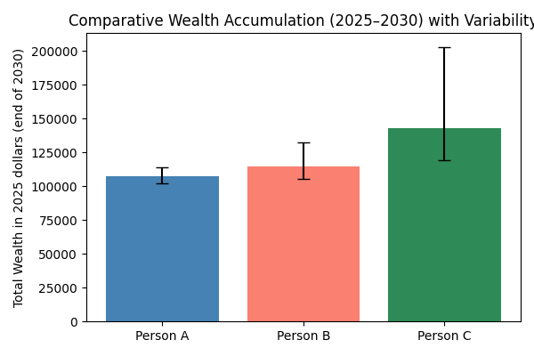

This comparison underscores the importance of diversification and risk tolerance. Conservative investors (Person A) may preserve capital but risk losing ground to inflation. Balanced strategies (Person B) offer steadier growth with manageable variability, while aggressive allocations (Person C) can double or triple purchasing power if digital assets and AI‑driven equities outperform but carry significant downside risk if those sectors falter.

These projections are illustrative and rely on simplified assumptions. Actual outcomes will vary based on market conditions, policy changes, tax considerations and personal circumstances. Nonetheless, the scenarios highlight how asset allocation, leverage, and exposure to emerging technologies can materially affect wealth growth and purchasing power over a five‑year horizon.

Artificial intelligence is an emerging catalyst. Investment and usage are skyrocketing; generative‑AI adoption, plummeting compute costs and accelerating hyperscaler capex indicate that AI’s economic impact will soon extend beyond technology firms. Research suggests material productivity gains may begin around **2027**[[48]](https://www.goldmansachs.com/insights/articles/ai-may-start-to-boost-us-gdp-in-2027#:~:text=Generative%20artificial%20intelligence%20has%20the,in%20the%20years%20that%20follow), while long‑term projections anticipate trillions in additional GDP[[44]](https://www.pwc.com/gx/en/issues/analytics/assets/pwc-ai-analysis-sizing-the-prize-report.pdf#:~:text=PwC%20research%20shows%20global%20GDP,making%20it%20the%20biggest%20commercial). Yet the transition will disrupt labour markets[[50]](https://myvalleynews.com/blog/2025/07/27/ai-revolution-to-replace-millions-of-jobs-within-two-years/#:~:text=As%20artificial%20intelligence%20rapidly%20evolves%2C,vanish%20or%20be%20drastically%20transformed), and the benefits will vary by region and sector.

In this complex environment, investors should watch for **policy changes**, **AI‑driven productivity data**, and **institutional crypto adoption**. Diversification across sectors—including defensive areas like consumer staples—remains prudent, especially as technological and regulatory landscapes continue to evolve.

[[1]](https://www.ameriprise.com/newsroom/commentary/where-do-markets-stand-five-years-after-pre-covid-19-highs#:~:text=A%20look%20at%20key%20market,19%20high) [[2]](https://www.ameriprise.com/newsroom/commentary/where-do-markets-stand-five-years-after-pre-covid-19-highs#:~:text=spending%20on%20goods%20and%20then,19%20environment) Newsroom | Ameriprise Newsroom

<https://www.ameriprise.com/newsroom/commentary/where-do-markets-stand-five-years-after-pre-covid-19-highs>

[[3]](https://www.investopedia.com/articles/forex/121815/bitcoins-price-history.asp#:~:text=In%202020%2C%20the%20economy%20shut,economy%20and%20accelerated%20Bitcoin%27s%20rise) [[4]](https://www.investopedia.com/articles/forex/121815/bitcoins-price-history.asp#:~:text=Bitcoin%20took%20less%20than%20a,2) [[5]](https://www.investopedia.com/articles/forex/121815/bitcoins-price-history.asp#:~:text=Important) Bitcoin's Price History

<https://www.investopedia.com/articles/forex/121815/bitcoins-price-history.asp>

[[6]](https://timesofindia.indiatimes.com/business/cryptocurrency/etherum/ethereum-changing-prices-and-trends-of-the-second-largest-cryptocurrency/articleshow/87889789.cms#:~:text=,06) Ethereum: Changing prices and trends of the second-largest cryptocurrency - Times of India

<https://timesofindia.indiatimes.com/business/cryptocurrency/etherum/ethereum-changing-prices-and-trends-of-the-second-largest-cryptocurrency/articleshow/87889789.cms>

[[7]](https://coinmotion.com/ethereum-price/#:~:text=Ethereum%20Price%20History%20to%20EUR,and%20USD) [[10]](https://coinmotion.com/ethereum-price/#:~:text=On%20January%202022%20Ethereum%20price,1%2C377%20USD%20and%201%2C156%20EUR) Ethereum price: How does it work & what affects ETH value

<https://coinmotion.com/ethereum-price/>

[[8]](https://www.globaldata.com/data-insights/financial-services/ethereums-price-history/#:~:text=By%202017%2C%20Ether%20had%20gained,it%20crossed%20the%20%241000%20mark) Ethereum’s Price History (2013 – 2023, $) - GlobalData

<https://www.globaldata.com/data-insights/financial-services/ethereums-price-history/>

[[9]](https://coinmarketcap.com/currencies/ethereum/#:~:text=All) Ethereum price today, ETH to USD live price, marketcap and chart | CoinMarketCap

<https://coinmarketcap.com/currencies/ethereum/>

[[11]](https://www.investopedia.com/articles/investing/041615/6-etfs-are-recessionproof.asp#:~:text=1,XLP) 6 ETFs That May Be Recession-Proof

<https://www.investopedia.com/articles/investing/041615/6-etfs-are-recessionproof.asp>

[[12]](https://www.whitehouse.gov/fact-sheets/2025/03/fact-sheet-president-donald-j-trump-establishes-the-strategic-bitcoin-reserve-and-u-s-digital-asset-stockpile/#:~:text=CREATING%20A%20STRATEGIC%20BITCOIN%20RESERVE,in%20government%20digital%20asset%20strategy) Fact Sheet: President Donald J. Trump Establishes the Strategic Bitcoin Reserve and U.S. Digital Asset Stockpile – ]

<https://www.whitehouse.gov/fact-sheets/2025/03/fact-sheet-president-donald-j-trump-establishes-the-strategic-bitcoin-reserve-and-u-s-digital-asset-stockpile/>

[[13]](https://www.fintechanddigitalassets.com/2025/03/president-trump-issues-executive-order-establishing-a-strategic-bitcoin-reserve/#:~:text=On%20March%206%2C%202025%2C%20President,medical%20supplies%2C%20and%20nuclear%20weapons) [[14]](https://www.fintechanddigitalassets.com/2025/03/president-trump-issues-executive-order-establishing-a-strategic-bitcoin-reserve/#:~:text=Democrats%20on%20the%20other%20hand%2C,the%20value%20of%20such%20reserves) President Trump Issues Executive Order Establishing a Strategic Bitcoin Reserve | Global Fintech & Digital Assets Blog

<https://www.fintechanddigitalassets.com/2025/03/president-trump-issues-executive-order-establishing-a-strategic-bitcoin-reserve/>

[[15]](https://financialservices.house.gov/news/documentsingle.aspx#:~:text=The%20House%20of%20Representatives%20looks,crypto%20capital%20of%20the%20world) [[16]](https://financialservices.house.gov/news/documentsingle.aspx#:~:text=%E2%80%9CThis%20is%20a%20historic%20opportunity,%E2%80%9D) House Announces Week of July 14th as “Crypto Week” | U.S. House Committee on Financial Services

<https://financialservices.house.gov/news/documentsingle.aspx>

[[17]](https://www.whitehouse.gov/fact-sheets/2025/07/fact-sheet-president-donald-j-trump-signs-genius-act-into-law/#:~:text=The%20White%20House) Fact Sheet: President Donald J. Trump Signs GENIUS Act into Law – The White House

<https://www.whitehouse.gov/fact-sheets/2025/07/fact-sheet-president-donald-j-trump-signs-genius-act-into-law/>

[[18]](https://www.npr.org/2025/07/17/nx-s1-5451413/crypto-week-stablecoin-genius-act-trump#:~:text=The%20House%20approved%20the%20GENIUS,change%20the%20world%20of%20commerce) [[19]](https://www.npr.org/2025/07/17/nx-s1-5451413/crypto-week-stablecoin-genius-act-trump#:~:text=So%2C%20what%20are%20stablecoins%3F) Congress passes 1st major crypto legislation in the U.S. : NPR

<https://www.npr.org/2025/07/17/nx-s1-5451413/crypto-week-stablecoin-genius-act-trump>

[[20]](https://www.reuters.com/legal/government/us-house-passes-stablecoin-legislation-sending-bill-trump-2025-07-17/#:~:text=July%2017%20%28Reuters%29%20,to%20sign%20it%20into%20law) US House passes stablecoin legislation, sending bill to Trump | Reuters

<https://www.reuters.com/legal/government/us-house-passes-stablecoin-legislation-sending-bill-trump-2025-07-17/>

[[21]](https://ripple.com/insights/q1-2025-xrp-markets-report/#:~:text=Ripple%E2%80%99s%20XRP%20Holdings%20Ripple%20reports,over%20the%20next%2042%20months) Q1 2025 XRP Markets Report | Ripple

<https://ripple.com/insights/q1-2025-xrp-markets-report/>

[[22]](https://coingape.com/trending/xrp-rich-list-june-2025-heres-who-owns-the-most-xrp/#:~:text=XRP%20comes%20with%20a%20total,For%20the%20same%20reasons%2C%20investors) XRP Rich List June 2025: Here's Who Owns the Most XRP?

<https://coingape.com/trending/xrp-rich-list-june-2025-heres-who-owns-the-most-xrp/>

[[23]](https://thecryptobasic.com/2025/05/15/here-is-how-much-xrp-ripple-holds-as-compared-to-the-last-quarter-of-2024/#:~:text=A%20recent%20report%20shows%20how,details%20on%20the%20ecosystem%E2%80%99s%20performance) Here Is How Much XRP Ripple Holds as Compared to the Last Quarter of 2024

<https://thecryptobasic.com/2025/05/15/here-is-how-much-xrp-ripple-holds-as-compared-to-the-last-quarter-of-2024/>

[[24]](https://www.investopedia.com/news/what-role-xrp-ripples-products/#:~:text=XRP%20is%20used%20as%20a,demand%20liquidity%20outside%20the%20U.S) [[25]](https://www.investopedia.com/news/what-role-xrp-ripples-products/#:~:text=Ripple%E2%80%99s%20products%20use%20XRP%20to,between%20two%20different%20fiat%20currencies) Ripple Ecosystem: What Is The Role of XRP?

<https://www.investopedia.com/news/what-role-xrp-ripples-products/>

[[26]](https://coindoo.com/here-are-the-top-bitcoin-billionaires-and-millionaires-of-2025/#:~:text=A%20fresh%20look%20at%20Bitcoin%E2%80%99s,and%20the%20numbers%20are%20staggering) [[28]](https://coindoo.com/here-are-the-top-bitcoin-billionaires-and-millionaires-of-2025/#:~:text=Other%20prominent%20names%20that%20fill,and%20outspoken%20advocates%20all%20included) [[29]](https://coindoo.com/here-are-the-top-bitcoin-billionaires-and-millionaires-of-2025/#:~:text=early%20investors%2C%20and%20corporate%20giants,and%20outspoken%20advocates%20all%20included) [[31]](https://coindoo.com/here-are-the-top-bitcoin-billionaires-and-millionaires-of-2025/#:~:text=) [[32]](https://coindoo.com/here-are-the-top-bitcoin-billionaires-and-millionaires-of-2025/#:~:text=) [[33]](https://coindoo.com/here-are-the-top-bitcoin-billionaires-and-millionaires-of-2025/#:~:text=) [[34]](https://coindoo.com/here-are-the-top-bitcoin-billionaires-and-millionaires-of-2025/#:~:text=,BTC) [[35]](https://coindoo.com/here-are-the-top-bitcoin-billionaires-and-millionaires-of-2025/#:~:text=,BTC) [[53]](https://coindoo.com/here-are-the-top-bitcoin-billionaires-and-millionaires-of-2025/#:~:text=Among%20the%20top%20twenty%3A) Here Are the Top Bitcoin Billionaires and Millionaires of 2025

<https://coindoo.com/here-are-the-top-bitcoin-billionaires-and-millionaires-of-2025/>

[[27]](https://www.investopedia.com/articles/people/083016/who-are-top-5-bitcoin-millionaires.asp#:~:text=Michael%20Saylor) Who Are the Top Bitcoin Millionaires?

<https://www.investopedia.com/articles/people/083016/who-are-top-5-bitcoin-millionaires.asp>

[[30]](https://www.coindesk.com/markets/2025/01/29/tesla-marked-up-bitcoin-holdings-valuation-in-q4-booking-a-usd600m-gain#:~:text=) Elon Musk's Tesla Booked a Q4 Gain on its Bitcoin (BTC) Holdings

<https://www.coindesk.com/markets/2025/01/29/tesla-marked-up-bitcoin-holdings-valuation-in-q4-booking-a-usd600m-gain>

[[36]](https://hai.stanford.edu/ai-index/2025-ai-index-report#:~:text=3,to%20show%20strong%20productivity%20impacts) [[37]](https://hai.stanford.edu/ai-index/2025-ai-index-report#:~:text=In%202024%2C%20U,that%20AI%20boosts%20productivity%20and) [[38]](https://hai.stanford.edu/ai-index/2025-ai-index-report#:~:text=Driven%20by%20increasingly%20capable%20small,the%20barriers%20to%20advanced%20AI) [[39]](https://hai.stanford.edu/ai-index/2025-ai-index-report#:~:text=8,on%20AI%E2%80%94with%20regulation%20and%20investment) [[40]](https://hai.stanford.edu/ai-index/2025-ai-index-report#:~:text=taking%20meaningful%20action,other%20core%20responsible%20AI%20principles) The 2025 AI Index Report | Stanford HAI

<https://hai.stanford.edu/ai-index/2025-ai-index-report>

[[41]](https://www.goldmansachs.com/insights/articles/the-outlook-for-ai-adoption-as-advancements-in-the-technology-accelerate#:~:text=a%20proxy%20for%20coding%20agents%2C,up%20about%2075x%20since%20then) [[42]](https://www.goldmansachs.com/insights/articles/the-outlook-for-ai-adoption-as-advancements-in-the-technology-accelerate#:~:text=OpenAI%E2%80%99s%20weekly%20average%20users%20when,probably%20north%20of%20a%20billion) [[43]](https://www.goldmansachs.com/insights/articles/the-outlook-for-ai-adoption-as-advancements-in-the-technology-accelerate#:~:text=The%20price%20of%20API%20tokens,100x%20since%20we%20talked%20last) The outlook for AI adoption as advancements in the technology accelerate | Goldman Sachs

<https://www.goldmansachs.com/insights/articles/the-outlook-for-ai-adoption-as-advancements-in-the-technology-accelerate>

[[44]](https://www.pwc.com/gx/en/issues/analytics/assets/pwc-ai-analysis-sizing-the-prize-report.pdf#:~:text=PwC%20research%20shows%20global%20GDP,making%20it%20the%20biggest%20commercial) [[45]](https://www.pwc.com/gx/en/issues/analytics/assets/pwc-ai-analysis-sizing-the-prize-report.pdf#:~:text=PwC%20research%20shows%20global%20GDP,boost) [[46]](https://www.pwc.com/gx/en/issues/analytics/assets/pwc-ai-analysis-sizing-the-prize-report.pdf#:~:text=contribute%20up%20to%20%2415,side%20effects) [[47]](https://www.pwc.com/gx/en/issues/analytics/assets/pwc-ai-analysis-sizing-the-prize-report.pdf#:~:text=PwC%20research%20shows%20global%20GDP,increases%20productivity%2C%20product%20quality%20and) Sizing the prize

<https://www.pwc.com/gx/en/issues/analytics/assets/pwc-ai-analysis-sizing-the-prize-report.pdf>

[[48]](https://www.goldmansachs.com/insights/articles/ai-may-start-to-boost-us-gdp-in-2027#:~:text=Generative%20artificial%20intelligence%20has%20the,in%20the%20years%20that%20follow) [[49]](https://www.goldmansachs.com/insights/articles/ai-may-start-to-boost-us-gdp-in-2027#:~:text=Generative%20artificial%20intelligence%20has%20the,in%20the%20years%20that%20follow) AI may start to boost US GDP in 2027 | Goldman Sachs

<https://www.goldmansachs.com/insights/articles/ai-may-start-to-boost-us-gdp-in-2027>

[[50]](https://myvalleynews.com/blog/2025/07/27/ai-revolution-to-replace-millions-of-jobs-within-two-years/#:~:text=As%20artificial%20intelligence%20rapidly%20evolves%2C,vanish%20or%20be%20drastically%20transformed) [[51]](https://myvalleynews.com/blog/2025/07/27/ai-revolution-to-replace-millions-of-jobs-within-two-years/#:~:text=A%20new%20workforce%20landscape) [[52]](https://myvalleynews.com/blog/2025/07/27/ai-revolution-to-replace-millions-of-jobs-within-two-years/#:~:text=As%20artificial%20intelligence%20rapidly%20evolves%2C,vanish%20or%20be%20drastically%20transformed) AI Revolution to replace millions of jobs within two years | Valley News

<https://myvalleynews.com/blog/2025/07/27/ai-revolution-to-replace-millions-of-jobs-within-two-years/>

[[54]](https://www.nikkoam.com.hk/files/sp/ark/pdf/2502_ark_big_ideas.pdf#:~:text=2030%20Price%20Target%20Bear%20Case,analysis%20is%20based%20on%20a) ARK Invest Big Ideas 2025

<https://www.nikkoam.com.hk/files/sp/ark/pdf/2502_ark_big_ideas.pdf>

[[55]](https://www.vaneck.com/us/en/blogs/digital-assets/matthew-sigel-ethereum-price-prediction-118k-by-2030/ethereum-price-prediction-118k-by-2030.pdf#:~:text=%241%2C983%20%24118%20%244%2C854%20ETH%20Price,performance%20is%20no%20guarantee%20of) Ethereum Price Prediction: $11.8k by 2030

<https://www.vaneck.com/us/en/blogs/digital-assets/matthew-sigel-ethereum-price-prediction-118k-by-2030/ethereum-price-prediction-118k-by-2030.pdf>

[[56]](https://investinghaven.com/ripple-xrp-price-predictions/#:~:text=XRP%20Price%20Prediction%20Overview) XRP Price Prediction 2025 2026 2027 - 2030 - InvestingHaven

<https://investinghaven.com/ripple-xrp-price-predictions/>

[[57]](https://www.rbcgam.com/documents/en/articles/long-term-capital-market-assumptions-Jan2024.pdf#:~:text=U,1.30%208.10%207.25) [[75]](https://www.rbcgam.com/documents/en/articles/long-term-capital-market-assumptions-Jan2024.pdf#:~:text=22,Emerging%20markets) RBC GAM long-term capital market assumptions

<https://www.rbcgam.com/documents/en/articles/long-term-capital-market-assumptions-Jan2024.pdf>

[[58]](https://www.morganstanley.com/ideas/innovation-technology-2030#:~:text=Humanoid%20Robots%3A%20Labor%20shortages%20caused,food%20preparation%2C%20logistics%20and%20manufacturing) [[59]](https://www.morganstanley.com/ideas/innovation-technology-2030#:~:text=Multi,creation%20and%20ecommerce%20up%207) [[64]](https://www.morganstanley.com/ideas/innovation-technology-2030#:~:text=What%20investors%20should%20know%3A%20Demand,segments%20of%20the%20power%20sector) Tech and Innovation: 2030 Outlook | Morgan Stanley

<https://www.morganstanley.com/ideas/innovation-technology-2030>

[[60]](https://www.mordorintelligence.com/industry-reports/residential-real-estate-market-in-usa#:~:text=The%20United%20States%20residential%20real,segments%20move%20in%20opposite%20directions) US Residential Real Estate Market Analysis | Trends, Forecast, Size & Industry Growth Report 2030

<https://www.mordorintelligence.com/industry-reports/residential-real-estate-market-in-usa>

[[61]](https://fortune.com/2024/06/12/tesla-stock-price-predictions-cathie-wood-ark-invest-elon-musk/#:~:text=ARK%20analysts%2C%20led%20by%20Tasha,Keeney%20and%20her%20team%20wrote) [[62]](https://fortune.com/2024/06/12/tesla-stock-price-predictions-cathie-wood-ark-invest-elon-musk/#:~:text=%E2%80%9COur%20research%20suggests%20that%20generalizable,dollar%20market%2C%E2%80%9D%20ARK%E2%80%99s%20analysts%20argued) Cathie Wood’s ARK Invest predicts Tesla stock will surge 1,345% over the next five years. Elon Musk says it’s an ‘extremely challenging, but achievable’ target | Fortune

<https://fortune.com/2024/06/12/tesla-stock-price-predictions-cathie-wood-ark-invest-elon-musk/>

[[63]](https://www.mitrade.com/au/insights/news/live-news/article-8-991171-20250728#:~:text=Then%20there%20is%20the%20Optimus,company%20over%20the%20long%20term) Elon Musk Thinks Tesla Will Become the World's Most Valuable Company. I Predict Its Stock Could Plunge by 70% (or More) Instead.

<https://www.mitrade.com/au/insights/news/live-news/article-8-991171-20250728>

[[65]](https://www.whitehouse.gov/articles/2025/07/white-house-unveils-americas-ai-action-plan/#:~:text=The%20White%20House%20today%20released,security%20for%20the%20American%20people) [[66]](https://www.whitehouse.gov/articles/2025/07/white-house-unveils-americas-ai-action-plan/#:~:text=,down%20ideological%20bias) [[67]](https://www.whitehouse.gov/articles/2025/07/white-house-unveils-americas-ai-action-plan/#:~:text=The%20White%20House%20today%20released,security%20for%20the%20American%20people) White House Unveils America's AI Action Plan – The White House

<https://www.whitehouse.gov/articles/2025/07/white-house-unveils-americas-ai-action-plan/>

[[68]](https://rentalhousingaction.org/congress-expands-the-housing-credit-in-budget-reconciliation-2/#:~:text=On%20July%204%2C%202025%2C%20President,Percent%20Credits%20enacted%20in%202020) Congress Expands the Housing Credit in Budget Reconciliation! – The ACTION Campaign

<https://rentalhousingaction.org/congress-expands-the-housing-credit-in-budget-reconciliation-2/>

[[69]](https://www.ropesgray.com/en/insights/alerts/2025/07/ai-and-tech-under-the-one-big-beautiful-bill-act-key-restrictions-risks-and-opportunities#:~:text=,R%26D%20%E2%80%93%20With%20Strings%20Attached) AI and Tech under the One Big Beautiful Bill Act: Key Restrictions, Risks, and Opportunities | Insights | Ropes & Gray LLP

<https://www.ropesgray.com/en/insights/alerts/2025/07/ai-and-tech-under-the-one-big-beautiful-bill-act-key-restrictions-risks-and-opportunities>

[[70]](https://www.whitehouse.gov/fact-sheets/2025/07/fact-sheet-president-donald-j-trump-continues-enforcement-of-reciprocal-tariffs-and-announces-new-tariff-rates/#:~:text=KEEPING%20AMERICA%20IN%20THE%20DRIVER%E2%80%99S,take%20effect%20on%20August%201) [[71]](https://www.whitehouse.gov/fact-sheets/2025/07/fact-sheet-president-donald-j-trump-continues-enforcement-of-reciprocal-tariffs-and-announces-new-tariff-rates/#:~:text=TAKING%20BACK%20OUR%20ECONOMIC%20SOVEREIGNTY%3A,our%20economic%20and%20national%20security) Fact Sheet: President Donald J. Trump Continues Enforcement of Reciprocal Tariffs and Announces New Tariff Rates – The White House

<https://www.whitehouse.gov/fact-sheets/2025/07/fact-sheet-president-donald-j-trump-continues-enforcement-of-reciprocal-tariffs-and-announces-new-tariff-rates/>

[[72]](https://www.rbc.com/en/thought-leadership/economics/featured-insights/us-inflation-outlook-a-squeeze-higher-in-second-half-of-2025/#:~:text=Our%20current%20US%20outlook%20can,end) [[73]](https://www.rbc.com/en/thought-leadership/economics/featured-insights/us-inflation-outlook-a-squeeze-higher-in-second-half-of-2025/#:~:text=,is%20mechanical%20but%20meaningful) [[76]](https://www.rbc.com/en/thought-leadership/economics/featured-insights/us-inflation-outlook-a-squeeze-higher-in-second-half-of-2025/#:~:text=Our%20current%20US%20outlook%20can,end) US inflation outlook: A squeeze higher in second half of 2025 - RBC

<https://www.rbc.com/en/thought-leadership/economics/featured-insights/us-inflation-outlook-a-squeeze-higher-in-second-half-of-2025/>

[[74]](https://economics.td.com/ca-long-term-forecast#:~:text=,the%20economy%20finds%20its%20balance) TD Economics - Long-Term Forecast

<https://economics.td.com/ca-long-term-forecast>